Thomas Schultz, 11/21/2022 Aggregate Queries

Showing the houses file.

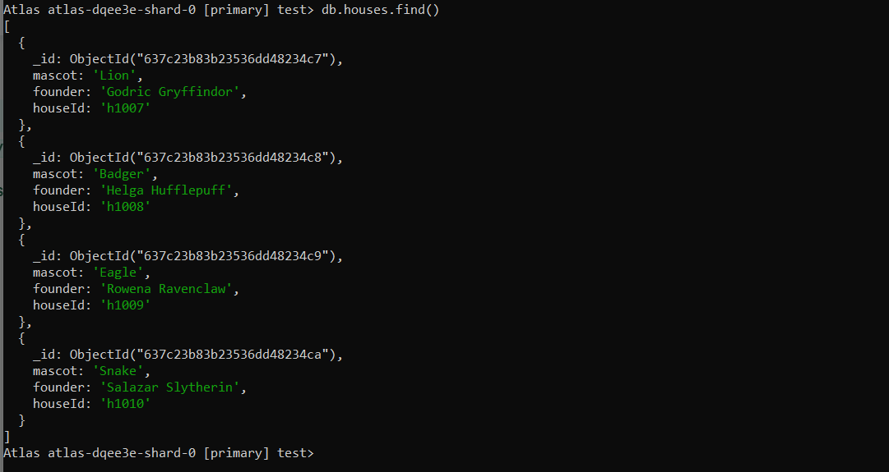

Showing the students.



This is inserting my name to the file

db.students.insertOne({firstName: "Thomas", lastName: "Schultz", studentId: "s1018", houseId: "h1007"})

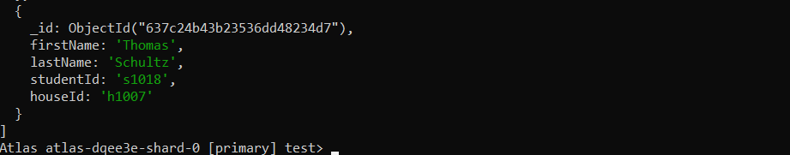

Deleting my name

db.students.deleteOne({lastName : “Schultz"})

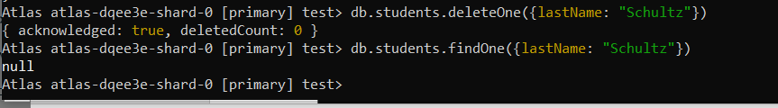

Seperating the houses and showing the students within each house.

db.houses.aggregate([{$lookup:{from: "students", localField: "houseId", foreignField: "houseId", as:"house_students"}}])

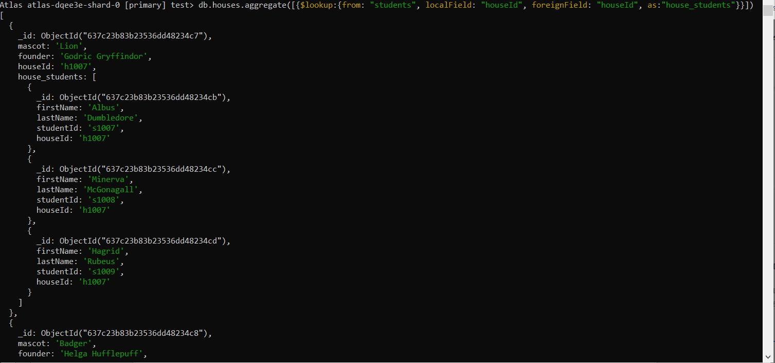

Showing the students in the given houseID which is Gryffinhor.

db.houses.aggregate([{$match: { "houseId": "h1007"}}, {$lookup: {from: "students", localField: "houseId", foreignField: "houseId", as: "house_students"}}])

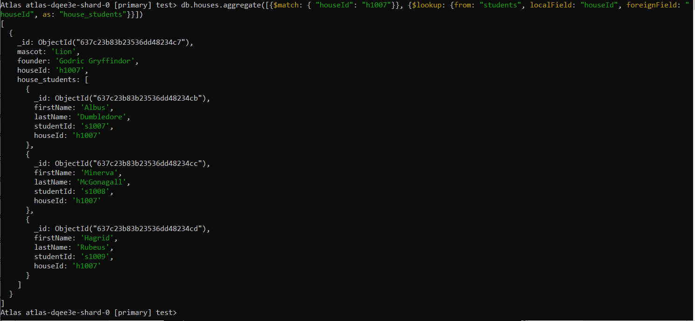

Showing the students with the mascot Eagle.

db.houses.aggregate([{ $match: {"mascot": "Eagle"}}, {$lookup: { from: "students", localField: "houseId", foreignField: "houseId", as: "mascot_students"}}])

